Professional Readiness for

**Innovation, Employability**

**And Entrepreneurship**

`

SMART HOME

SUBMITTED BY

S. SANTHIYA

961819106045

B12-6A2E

MOTION DETECTION USING IR SENSOR

CODE:

int pirsensor =0;

void setup()

{

pinMode(2, INPUT);

pinMode(12, OUTPUT);

pinMode(13, OUTPUT);

}

void loop()

{

pirsensor = digitalRead(2);

if(pirsensor == HIGH)

{

//glow led

digitalWrite(13,HIGH);

// ring buzzer

tone(12,500,500);

}

digitalWrite(13,LOW);

}

TINKERCAD LINK:

<https://www.tinkercad.com/things/4H8suIKoLhK>

FIGURE:

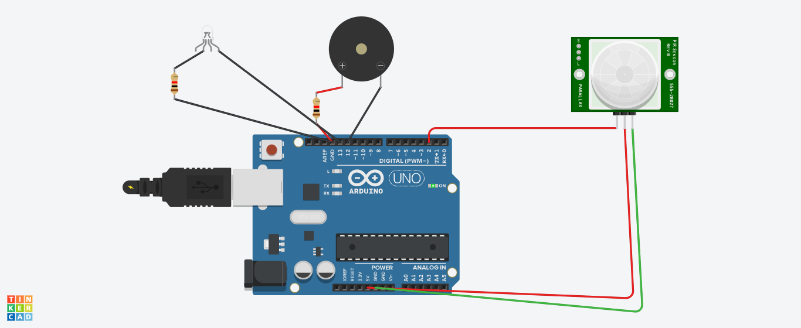

**Whenever anyone comes in the path or range of IR sensor**, microcontroller detects the distance of object from the sensor and if the object is in the defined range it sends the high signal to buzzer and buzzer start beeping at the same time light is emitting.